Carrot and Date Muffins 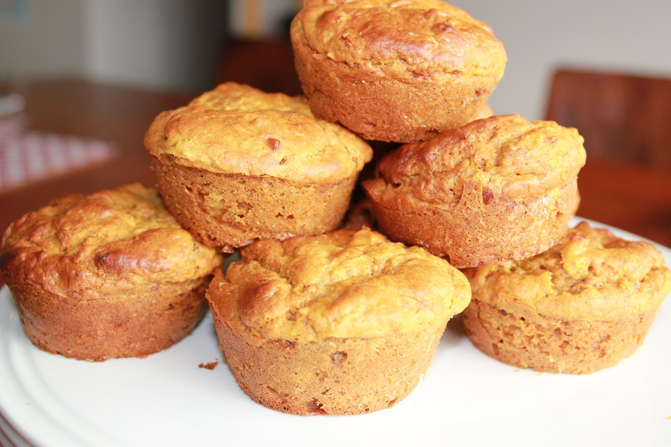

These gluten, dairy and nut free muffins are perfect for lunch boxes and make a great grab ‘n’ go breakfast.

You will need:
1 ½ cups of gluten free flour (or plain if you’re not GF)
2 tsp baking powder
½ tsp baking soda
1 cup grated carrots
1 cup chopped pitted dates
¼ cup oil (macadamia is best, light tasting olive oil or coconut is also fine)
¼ -½ cup of honey or rice malt syrup, melted (depending on your desired sweetness level)
½ cup coconut or alternate milk (I like the consistency coconut milk adds)
2 eggs

This is a super simple recipe.
Bellini/Thermomix/food processor
Heat oven to 180 degrees.
Roughly chop the carrots so they’re not too big for your machine. Whizz them up on speed 6 for 5 seconds.
Add the dates and whizz on speed 6 for 10 seconds.
Add flour, baking powder, baking soda, oil, honey, milk and eggs to the bowl.
Mix on speed 3 for 20 seconds to mix it all up.
Pour into muffin tins and bake for approximately 20 minutes.

Old School method:
Grate your carrots and finely chop the dates.
Add the rest of the ingredients and stir until well combined.
Pour into muffin tins and bake for approximately 20 minutes.

Good luck having any left for school!

